Development of temperature and relative humidity profiles from the Uinta Basin Ozone NAA for mobile source emissions modeling in MOVES
Mobile emissions modeling requires diurnal temperature and relative humidity (RH) profiles that are representative of the region of interest. Because the Uinta Basin experiences ozone exceedances episodically during the wintertime, single profiles of temperature and RH will be used to represent a specific ozone episode. To complete this analysis, meteorological data from the airport in Vernal, Utah (KVEL) was acquired from the MesoWest Archives. Mesowest (mesowest.utah.edu) is a database of current and archived meteorological data from weather stations in the United States maintained by the University of Utah. The approach for developing temperature and RH profiles are described below.
We selected a specific ozone exceedance event in the Uinta Basin NAA of February 1st through 10th, 2013. We will use this particular episode for future state implementation plan (SIP) demonstrations. Hourly temperature and relative humidity (RH) data for these 10 days were acquired for KVEL. We believe KVEL is representative of the Uinta Basin NAA because the Vernal monitor experienced the same ozone exceedances as other monitors in the basin during the 2013 episode, and the elevation of the airport (~1600 meters) is between the highest (6250 m) and lowest (~ 1400 m) elevations of the NAA.
Average hourly profiles were developed from the MesoWest data (Figure 1), with each average value representing 10 datapoints. Figure 1 shows the specific temperature and RH profiles of this 10-day episode compared to the 10-year climatological average for the month of February. The 2013 episode is cooler with higher RH than the climatological average which is representative of the temperature inversion experienced during the event. Because the ozone episodes experienced in the Uinta Basin are characterized by capping inversions and local emission sources, we are not concerned with long-range transport from other counties. For this reason, only one set of temperature and RH profiles will be used to run MOVES for the entire state.
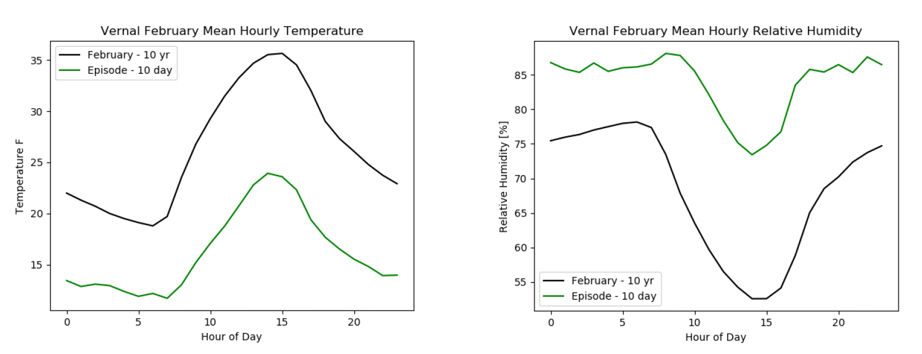
Figure 1: Temperature and relative humidity profiles for Vernal regional airport. Profiles of the 10-year climatological average for February (black) and for the 10-day episode (green) are shown.

